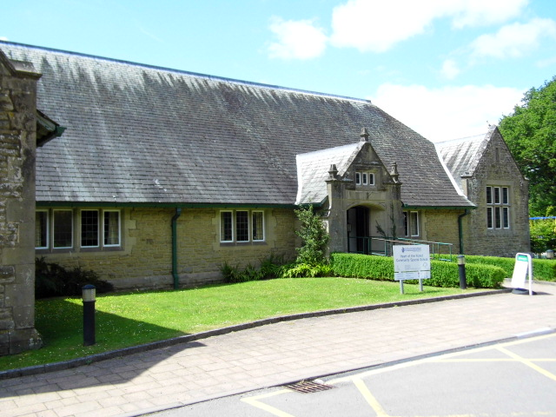
Heart of the Forest Community Special School
Deputy Head Application Pack – December2025

Head Teachers Welcome Letter

Dear Candidates,

Heart of the Forest Community Special School is an all age (4-19) specialist provision situated within the beautiful Royal Forest of Dean. Our school meets the educational needs of 160 pupils with PMLD, SLD and complex needs, all with an EHCP.

Heart of the Forest Community Special School aims to engage, enrich and inspire, equipping pupils for their current and future stages in life. Our school has a strong and ambitious vision to create relevant opportunities to build skills and knowledge through an aspirational and personalised curriculum, inspiring meaningful experiences and connections with the wider world.

The Forest of Dean is a very close community, which enhances the ‘family feel’ that our special school celebrates and works hard to preserve. We endeavour to take every advantage of our stunningly beautiful surroundings, ensuring that learning reaches beyond the classroom. The school is on an improvement journey as reflected in our Ofsted report from February 2025. It is an exciting time to join the school and shape the future.

Our school is recruiting for a Deputy Headteacher who will take on a key role in our developmental journey. Our new headteacher, Lucyna Mansfield, returns from maternity leave in September 2026. We are keen for our new Deputy Head to join the leadership team from April 2026 to gain a good understanding of the pupils and vision ready to support Lucyna from September. The role commands high professional standards and a commitment to developing the teaching and learning of special needs within a supportive provision. Our pupils are at the centre of all of our decisions and we continually strive to make a difference.

We are lucky to have a highly committed and skilled Governing Body who work relentlessly to support the school and act as critical friends on our improvement journey.

We look forward to meeting you and sharing our school.

Diana Denman and Lyn Dance
Co Headteachers

Our Vision

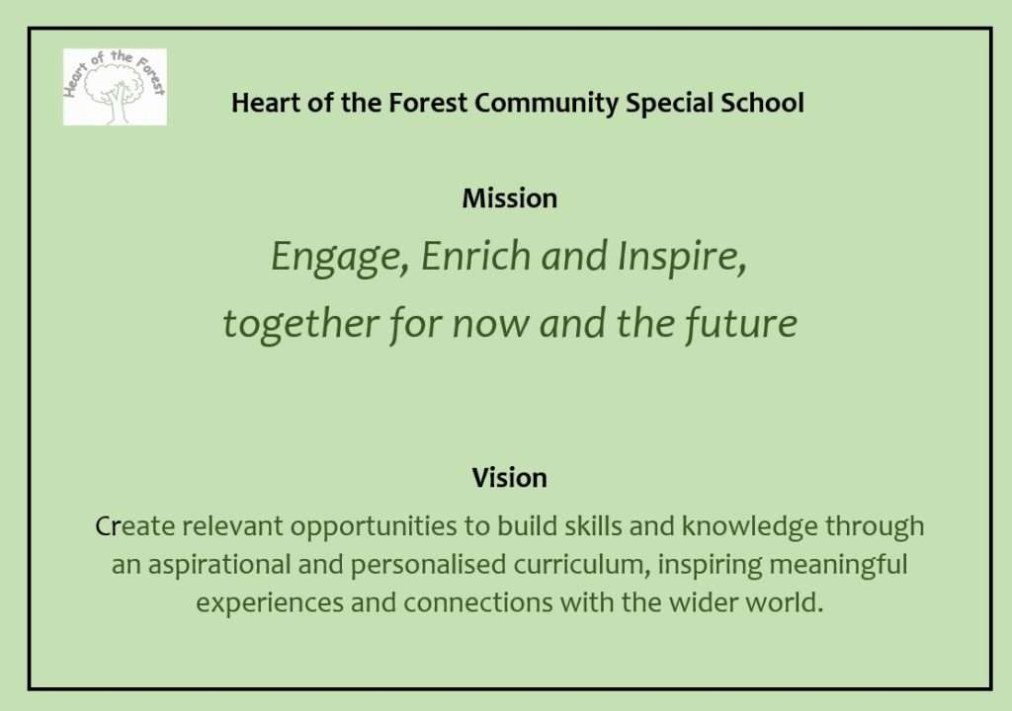
Job description

Position: | Deputy Headteacher
Reports to: | Head Teacher
Line management responsibilities | Middle Leaders and subject leads
Teaching commitment | Non teaching, although may be called on to occasionally cover staff absence.
Grade: | Leadership Scale 15-19

Key purpose of the job

The duties outlined in this job description are in addition to those covered by the latest School Teachers’ Pay and Conditions Document. It may be modified by the head teacher, with your agreement, to reflect or anticipate changes in the job, commensurate with salary and job title.

Main activities:

- To assist the head teacher in the leadership and management of the school and in all aspects of school improvement, including taking full responsibility for the school in the absence of the head teacher.
- To take full responsibility for leading and managing significant aspects of the school, under the overall direction of the head teacher.
- To carry out teaching duties, if required, in accordance with the new Ofsted framework.
- To deputise for the Head teacher where appropriate.
- To undertake performance management of staff

Leadership and Management

General responsibilities

- To assist the head teacher in shaping a vision and direction for the school, setting out very high expectations and with a clear focus on pupil achievement.
- To play a significant role in setting aims and objectives for the school and in formulating the School Development Plan along with the head teacher, governors and other senior staff. To take responsibility for developing and monitoring policy and practice as laid down in the School Development Plan, and in agreement with the head teacher.
- To inspire, motivate and influence staff and pupils, taking a leading role in maintaining the highest standards of teaching, learning and pupil discipline.
- To provide an excellent role model for all members of staff and for pupils in all aspects of school life. To be an exemplar of all school policies and practices. To actively promote the aims of the school. To offer guidance and support to colleagues.
- To take a leading role in improving the involvement of parents, carers and the community in the life of the school.
- To assist the head teacher in school self review and evaluation and in the effective planning and management of school resources to secure improvements.
- To maintain an informed view of standards and of the quality of teaching across the school by monitoring pupils’ work and teachers’ planning and teaching, in line with the new Ofsted framework.
- To assist the head teacher in all aspects of the day –to – day administration and organisation of the school, as agreed with the head teacher, including taking responsibility for agreed areas, e.g. timetables, duty rotas etc.
- To take a significant role in the implementation of the school staff appraisal policy, to secure school improvement and individual professional development.
- To participate in recruitment and selection, as agreed with the head teacher.
- To ensure the appropriate chairing annual reviews.

Specific responsibilities

- To lead on staff recruitment, deployment and organising supply cover as appropriate.
- To have leadership responsibility for developing and maintaining high standards of assessment, recording and reporting across the school for a range of audiences; teachers, parents, governors, LA, Ofsted and other stakeholders. To lead on whole school data tracking.
- To lead on the Quality of Education Assurance in the school with regard to curriculum, ensuring clear intent, and managing the effective implementation and monitoring the impact. Ensuring successful outcomes for all pupils.
- To coordinate the school’s continuing professional development programme as part of SLT role, including co-ordinating training programmes, delivering INSET and working with individuals and teams in a variety of professional development activities, taking into account national and local initiatives and school improvement priorities in order to impact on pupil achievement and staff personal development.
- Review induction process and delegate induction appropriately to middle leaders and Senior TAs.
- Lead on ECT programme and take on role of Induction Tutor.
- Support the DSL as a DDSL alongside other delegated members of staff.
- To lead on staff well being. This includes monitoring of staff absence and implementation of the staff absence policy in liaison with Assistant Heads and Senior TAs
- To lead on the management of EHCP’s and pupil banding reviews
- To lead on smooth transition of new pupils into school and pupils leaving school to ensure best possible pupil outcomes
- To ensure high standards of teaching across through monitoring, supportive plans and signposting to appropriate support within school.
- Ensure aspirational and successful outcomes for pupils and that high quality education is provided in the classroom and beyond.
- Commitment to personal professional development.

Other duties and responsibilities

- To attend daily and weekly meetings, in accordance with school policy and to lead such meetings as required.
- To take school assemblies/worship if requested to
- To attend occasional meetings during evening hours, at weekends or in the school holidays, as required.
- To perform investigations such as those relating to safeguarding or conduct.

Key organisational objectives

The Post holder will contribute to the school’s objectives in service delivery by:
- Commitment and contribution to improving standards for pupils as appropriate
- Contributing to the maintenance of a caring and stimulating environment for pupils
- Enactment of Health and Safety requirements and initiatives as directed
- Compliance with Data Protection legislation
- At all times operating within the school’s equal opportunities framework

Heart of the Forest is committed to safeguarding and promoting the welfare of children and young people and expects all staff and volunteers to share this commitment. As part of the selection process we will undertake checks to ensure that you do not pose of risk of harm to children and young people.

Equal Opportunity
The council is committed to ensuring equality of opportunity and fairness in the workplace, and providing equality of access to services for the communities it serves.

The post holder will be expected to carry out all duties in the context of and in compliance with the Council’s Equal Opportunities Policies.
Deputy Head - Person Specification
Requirement | Essential | Desirable
Qualifications and Training | - Qualified teacher status  - Degree  - Evidence of continuing and recent professional development relevant to the post  - Prepared to complete a relevant leadership qualification within first year eg NPQH or NPQSL | - Team teach Qualified  - Leadership training e.g. NPQH/SL  - Experience working in a special school
Knowledge and understanding | - Understanding of Heart of the Forest’s vision for our young people and a commitment to implementing this  - Current theory and best practice in teaching and learning for pupils with a range of complex needs, as well as typical development in young children  - Effective leadership and management in relation to raising pupils’ achievement and school improvement  - The importance of the culture and ethos of a school in securing consistent best practise and of strategies for improving these  - Understanding the barriers to learning in a special needs setting  - How opportunities can be made to enrich and enhance the curriculum to address the needs of all pupils  - Understand the role of parents/carers and the community in school improvement and how this can be promoted and developed  - Commitment to the protection and safeguarding of children including an understanding of child protection issues and procedures  - Understanding of Equality of Opportunity issues and how they can be addressed in schools
Experience | - Recent, significant and successful experience as a teacher working with pupils with Complex Needs  - A proven track record of raising attainment  - Significant and successful experience of leading aspects of the curriculum at whole school level  - Experience of contributing to school improvement, as a member of a leadership team  - Track record of supporting/mentoring colleagues in order to secure school improvement  - Successful experience of improving the quality of teaching and learning, through processes of monitoring and support  - Experience of managing and using pupil attainment and tracking data bases  - Experience of developing and leading staff development programmes for teachers and other staff  - Experience of initiating and implementing strategies to improve parental involvement in their children’s learning  - Experience of middle leadership and track record of high autonomy in decision making.  - Experience of Teaching and Leadership across a range of Key Stages and Special Educational needs.  - Proven track record of implementing change at a strategic level. | - Experience of delivering INSET to a whole staff group
Aptitude and skills | - To have high aspirations for pupil outcomes  - Able to promote an ethos of ‘continual improvement’ within the school community and other schools  - Demonstrate leadership qualities, including energy, emotional resilience and the ability to enthuse and motivate others  - Able to articulate a clear vision for high quality education in a rural setting  - Have a good personal presence, good communication skills and a sense of humour  - Able to communicate clearly both orally and in writing with a diverse range of audiences, including children, parents and carers, governors, staff and outside agencies  - Relate well to children and be responsive to their wide ranging needs  - Able to develop and maintain effective relationships with all members of the school community and outside agencies  - Approachable, accessible and flexible, including flexibility to extend working hours where required  - Able to work effectively under pressure, to prioritise appropriately and to meet deadlines in a fast changing environment  - Good analytical skills, able to synthesise complex information, summarise, draw appropriate conclusions and make decisions  - Able to understand, interpret and present school performance and financial data  - Able to effectively use IT to communicate and understand and present data | - Team teach trained or wiling to complete

How to Apply

In addition to the information contained within this pack, you can find out more about our school by visiting our website at www.heartoftheforestschool.co.uk

Copies of our Safeguarding and Safer Recruitment Policies can be found on the Vacancies page of our website.
You are also encouraged to visit the school before completing your application. Please contact: Laura Small on 01594 822175 to make an appointment.

We hope that when you have completed your research you will be excited at the prospect of joining us at Heart of the Forest. So please read the person specification carefully and take the opportunity to demonstrate that you have the qualities that we are looking for when you complete the application form.

Please submit your application to Wendy Gallagher, Governor Services, Gloucestershire County Council. Email: governor.services@gloucestershire.gov.uk

The key dates of the selection process are:

Closing Date: Friday 23rd January 2026

Interviews: Thursday 5th and Friday 6th February 2026

